1. Introduction
The purpose of this project is to develop a single-page personal portfolio website using strictly semantic HTML5. The website was created without CSS or inline styling so that the page relies entirely on the browser's default layout and demonstrates the structural capabilities of HTML5.
HTML, or HyperText Markup Language, provides the basic structure of documents displayed on the World Wide Web. Semantic HTML uses elements according to their meaning and purpose rather than using elements only for visual presentation (Mozilla Developer Network, 2025). This approach makes the structure of a website clearer for developers, browsers, and assistive technologies.
The portfolio created for this assignment contains a header, navigation menu, personal biography, profile image, technical skills, project information, contact form, and footer. The project also demonstrates the use of internal navigation links, descriptive lists, articles, accessible form labels, and external repository links.

The main objectives of this project were:
- To create a valid HTML5 document.
- To use semantic HTML5 elements correctly.
- To create a simple personal portfolio.
- To provide accessible navigation and form controls.
- To validate the HTML using the W3C HTML Validator.
- To publish the project source code through GitHub.
- To understand the importance of semantic and structured web development.

2. Project Implementation
2.1 HTML5 Document Structure
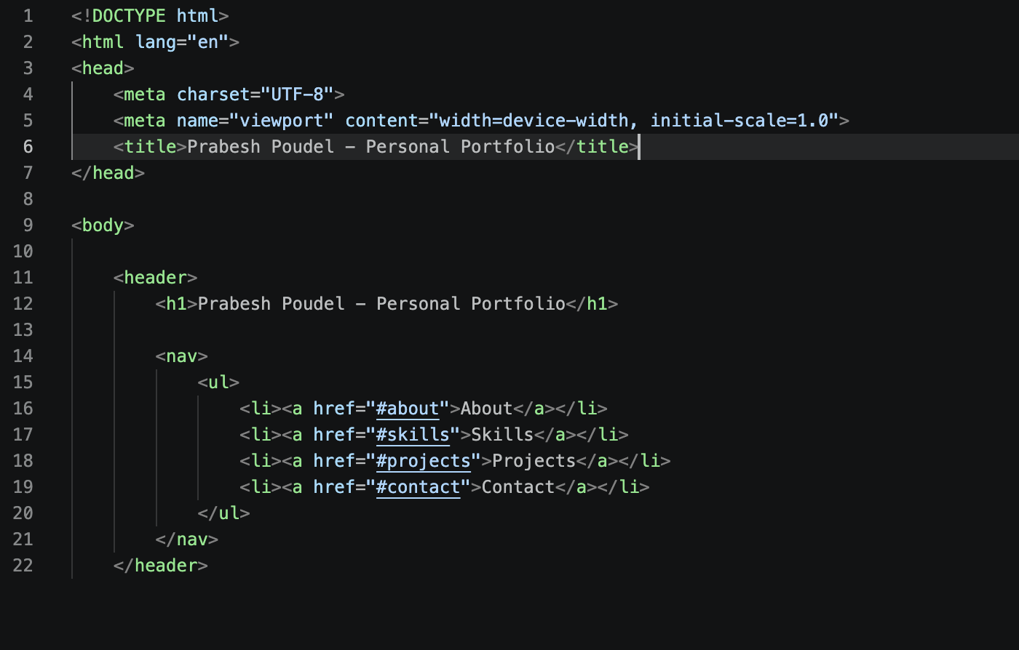
Figure 1: HTML5 Document Structure and Header Navigation
The project begins with the HTML5 document declaration:

<!DOCTYPE html>
The document also specifies English as its primary language using the lang="en" attribute. The <head> section contains the character encoding, viewport information, and page title.

No CSS file, <style> element, or inline style attribute has been used. Therefore, the website is displayed using the browser's default formatting as required by the assignment.

According to WHATWG (2026), HTML provides elements that allow authors to structure documents and describe different types of content. The project therefore uses semantic elements such as <header>, <nav>, <main>, <section>, <article>, and <footer>.

2.2 Header and Navigation
The <header> element contains the main heading of the portfolio. The primary title is presented using an <h1> element.
The navigation area is contained inside a <nav> element. An unordered list <ul> is used to organize the navigation links. Each link points to a specific section of the same page using an ID.

The navigation includes:
- About
- Skills
- Projects
- Contact

For example, the About link points to the element with id="about". This allows visitors to move directly to different areas of the portfolio.

2.3 About Section
The About section contains a short biography and a profile image. The image is stored in the local images directory.
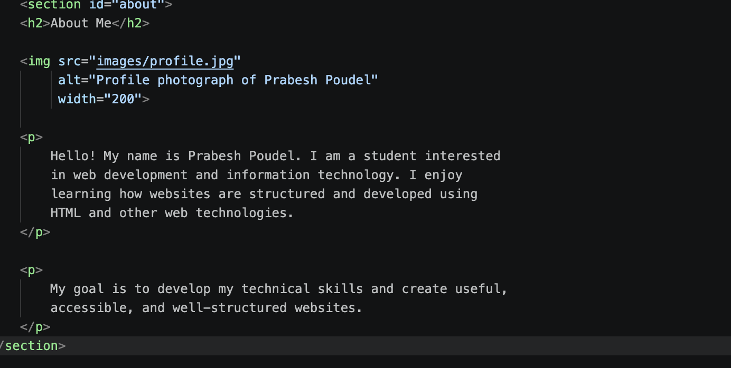
Figure 2: About Section and Profile Image
The image uses an alt attribute:

- alt="Profile photograph of Prabesh Poudel"
- Alternative text provides a textual description of an image and can assist users who cannot see the image or when the image cannot be displayed.
- The biography introduces the student and describes an interest in web development and information technology.

2.4 Technical Skills
The Technical Skills section uses a description list.
The <dl> element contains individual <dt> and <dd> pairs. The <dt> identifies a skill, while the <dd> provides a description.
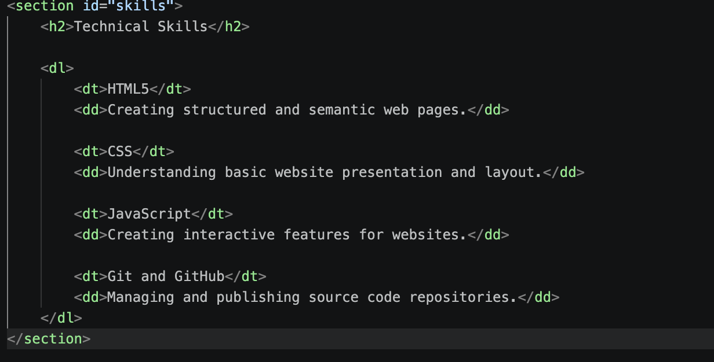
Figure 3: Technical Skills Description List

The skills included in the portfolio are:
- HTML5
- CSS
- JavaScript
- Git and GitHub

Using a description list provides a meaningful relationship between each technical skill and its explanation.

2.5 Projects
The Projects section contains two independent project modules.
Each project is contained within an <article> element. This is appropriate because each project represents an independent piece of content.
The first project is the Personal Portfolio Website. The second project is a Student Web Development Project.
Each project contains a description and a repository link. The repository links will direct users to the corresponding public GitHub repositories.
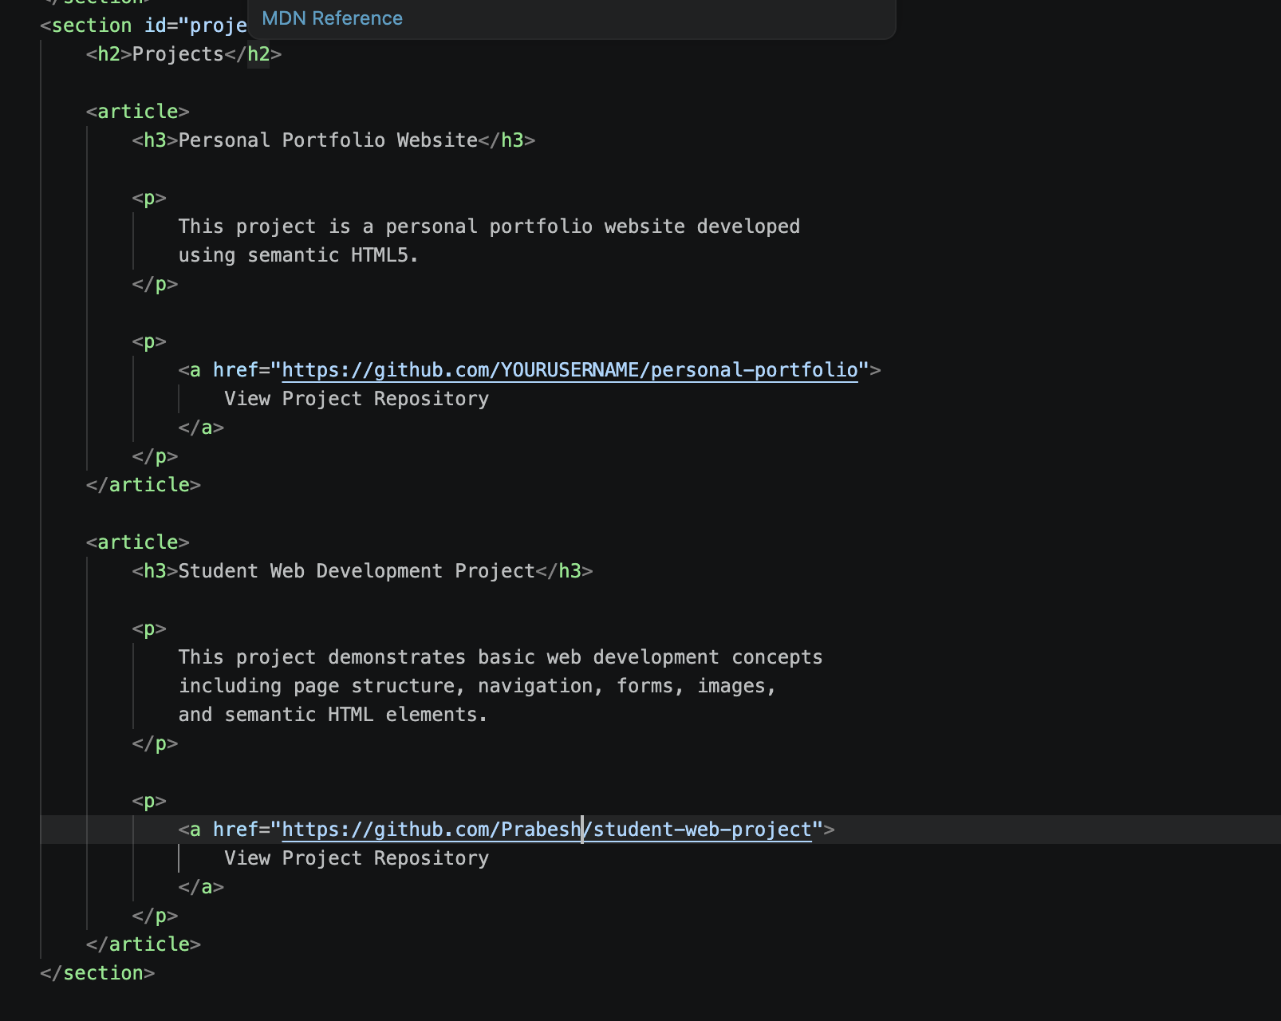
Figure 4: Projects Section Using Article Elements

2.6 Contact Form
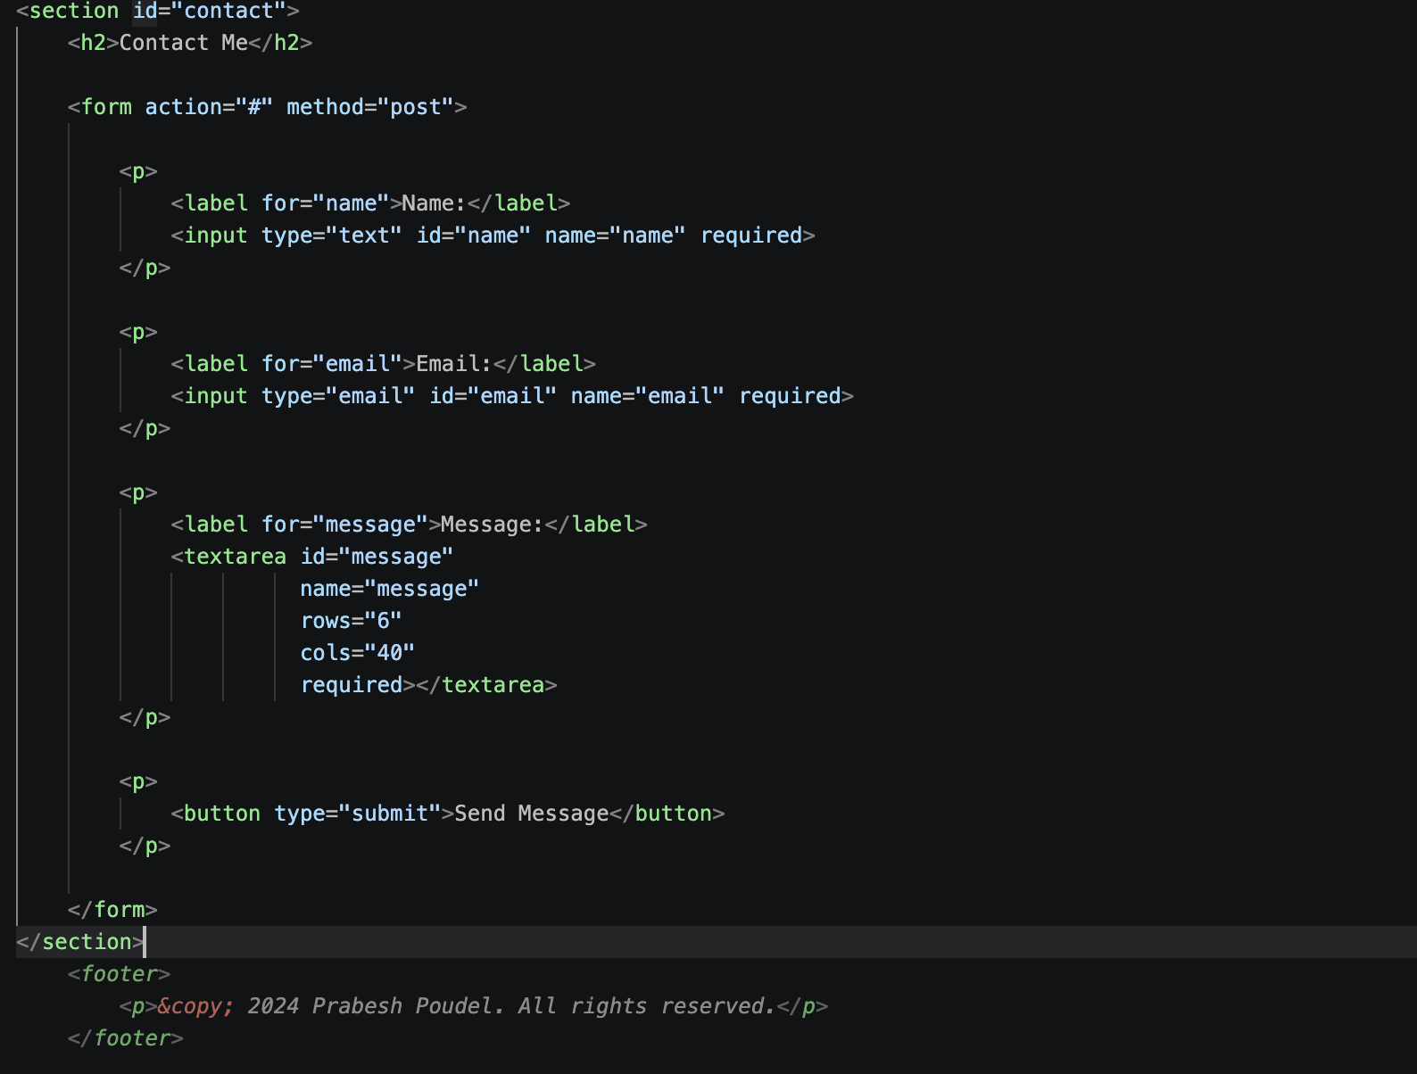
Figure 5: Contact Form Implementation
The Contact section contains a simple HTML form.
The form includes:
- Name input
- Email input
- Message textarea
- Submit button

Each form control has an explicitly associated <label>. The for attribute of each label matches the id of the corresponding form control.

For example:
<label for="email">Email:</label>
is associated with:
<input type="email" id="email" name="email">
This provides a clearer and more accessible form structure.

The required attribute is also used for the fields so that the browser checks that information has been entered before submission.

3. Results and Testing
After completing the HTML document, the website was opened in a web browser to verify that all required sections were displayed correctly.

Because the assignment specifically prohibits CSS and inline styling, the page uses the browser's default HTML presentation. The result is a simple and clearly structured portfolio containing headings, paragraphs, navigation links, an image, a skills list, project articles, and a contact form.

Figure 1: Portfolio Source Code
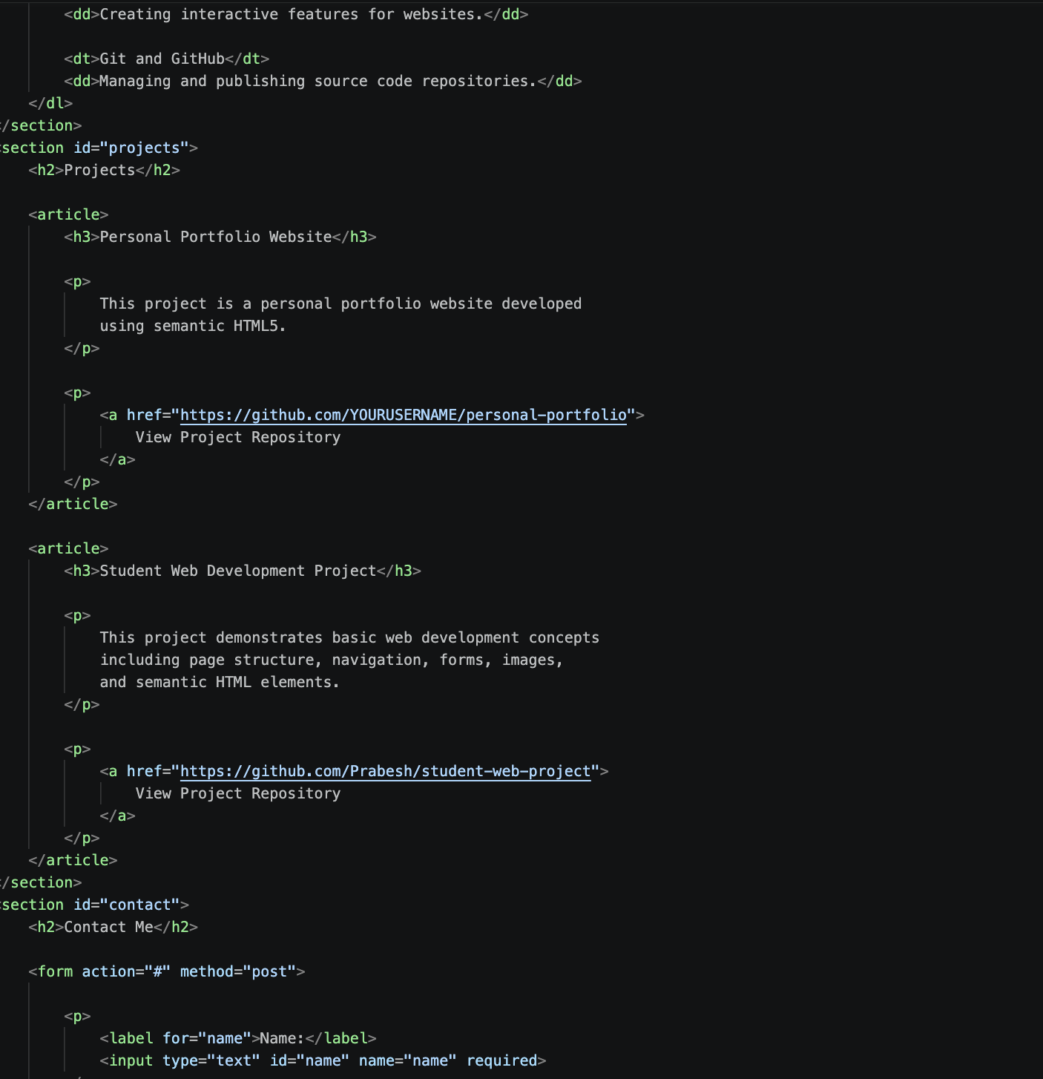
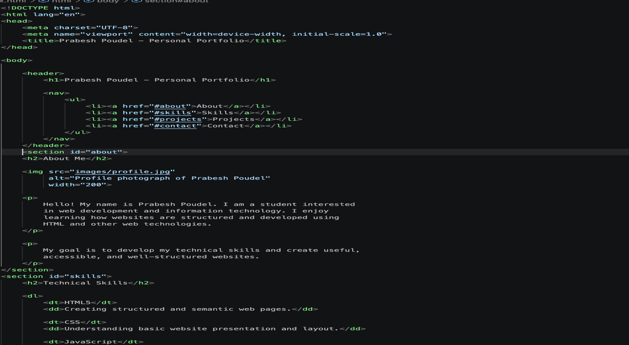
The source-code screenshot should clearly show the semantic HTML elements used in the project.

Figure 2: Portfolio Website Output
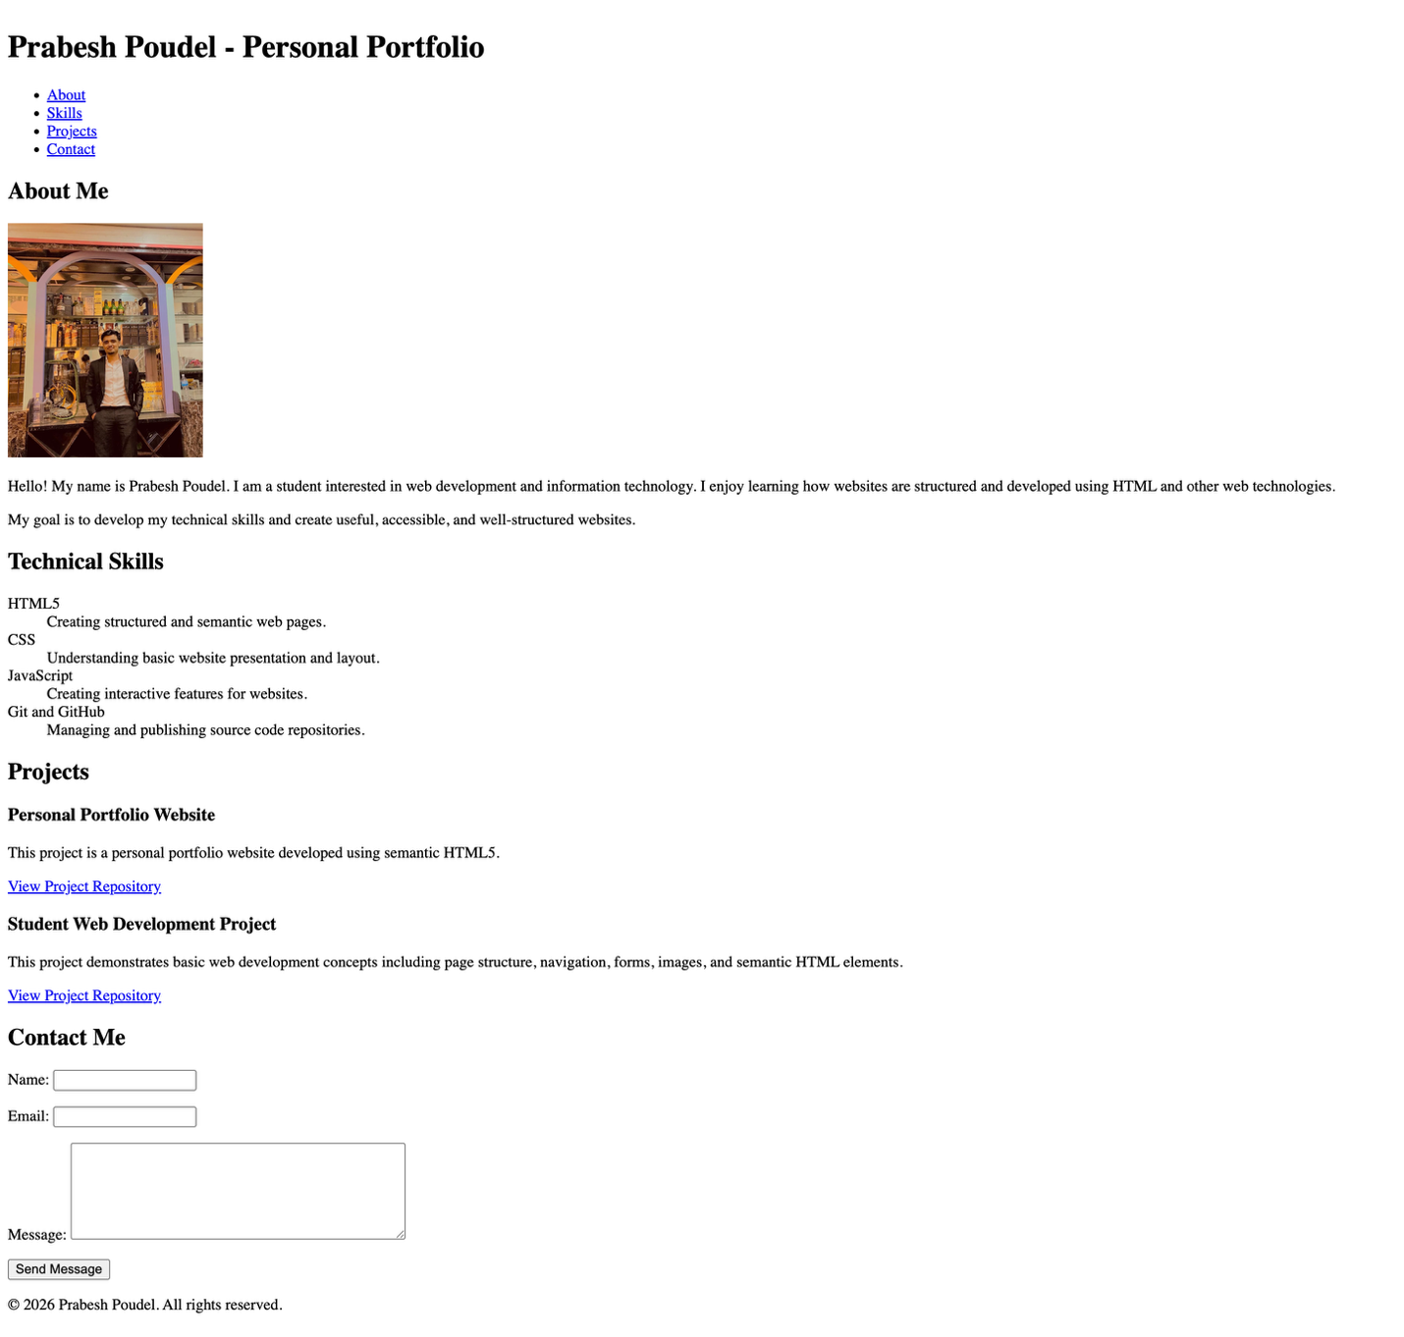
The output screenshot should show the complete portfolio page, including the navigation, About section, Skills section, Projects section, Contact form, and footer.

3.1 W3C Validation
The HTML document was tested using the W3C Markup Validation Service. The purpose of validation is to identify errors in the HTML document and verify that the markup follows the relevant HTML specification.

Figure 3: W3C HTML Validator Result
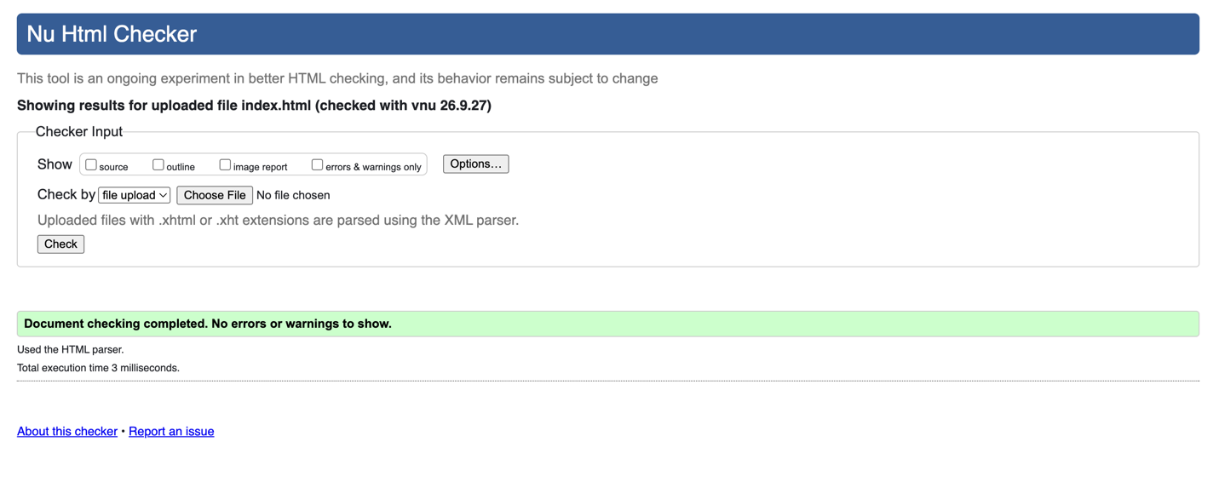
The final screenshot should clearly demonstrate a successful validation with zero HTML errors.
Validation was performed after completing the page to ensure that incorrect markup, missing attributes, or structural problems could be identified and corrected before submission.

3.2 GitHub Repository
The completed project source code is also intended to be uploaded to a public GitHub repository. The repository contains the index.html file and the images directory containing the profile image.

GitHub Repository:
[INSERT YOUR PUBLIC GITHUB REPOSITORY LINK HERE]

The GitHub repository allows the project source code to be accessed and evaluated independently from the local development environment.

4. Conclusion
The Semantic HTML5 Personal Portfolio project provided an opportunity to practice creating a complete webpage using HTML5 without relying on CSS or external frameworks.
The project demonstrated the use of semantic structural elements including <header>, <nav>, <main>, <section>, <article>, and <footer>. It also demonstrated the use of images with alternative text, description lists, internal navigation links, project repository links, and accessible form labels.
One of the main lessons from this project was the importance of separating document structure from visual presentation. Although the portfolio does not use CSS, the semantic HTML provides a clear organization of the page content. Semantic markup can also improve the understanding of a document's structure for browsers, developers, and assistive technologies (Mozilla Developer Network, 2025).
The validation process was another important part of the project. Testing the completed HTML with the W3C validator helped ensure that the final document contained valid markup. Publishing the project on GitHub also provided experience with source-code management and public project sharing.
Overall, the project strengthened my understanding of HTML5 document structure, semantic elements, accessibility, form design, validation, and basic GitHub repository management.

References
Mozilla Developer Network. (2025). HTML: HyperText Markup Language. MDN Web Docs.
https://developer.mozilla.org/en-US/docs/Web/HTML
WHATWG. (2026). HTML living standard. https://html.spec.whatwg.org/
World Wide Web Consortium. (n.d.). Markup validation service. W3C. https://validator.w3.org/

